March 13th,

**VBA Homework - The VBA of Wall Street**

**Results: 2014**

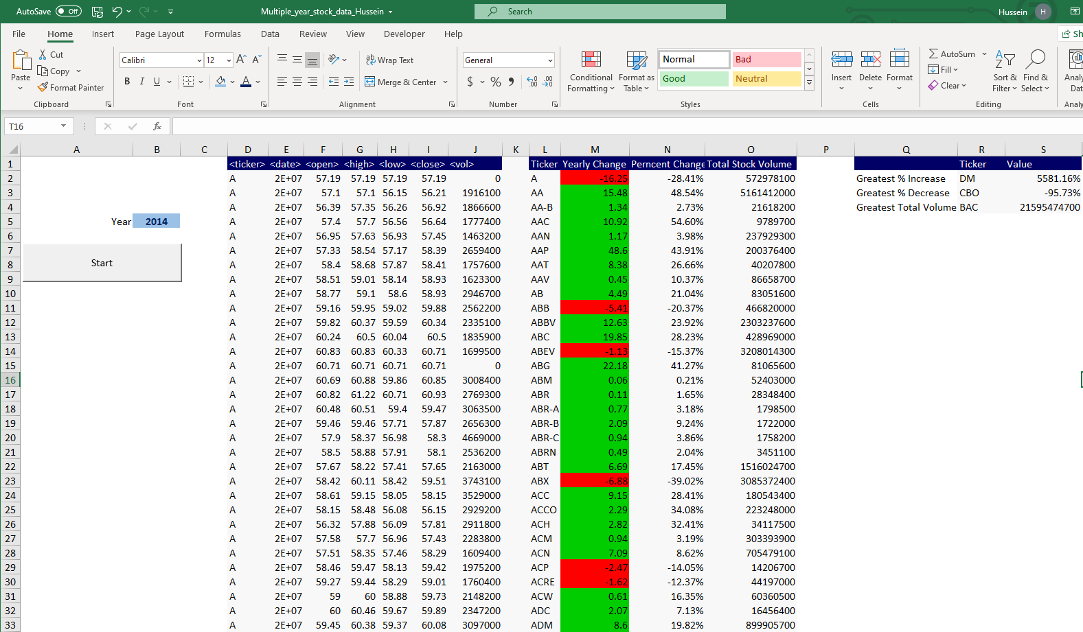

**Results: 2015**

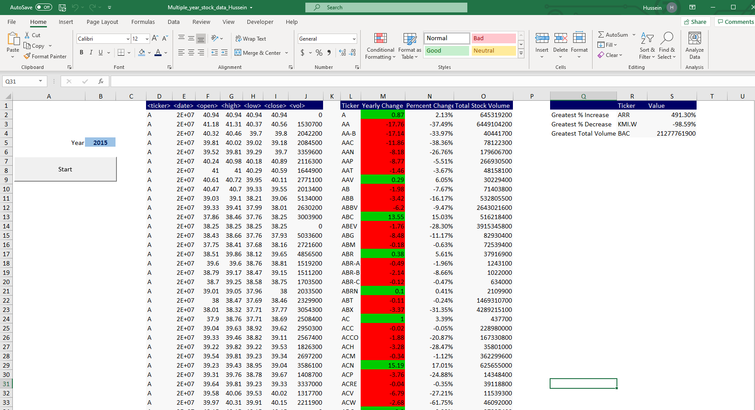

**Results: 2016**

